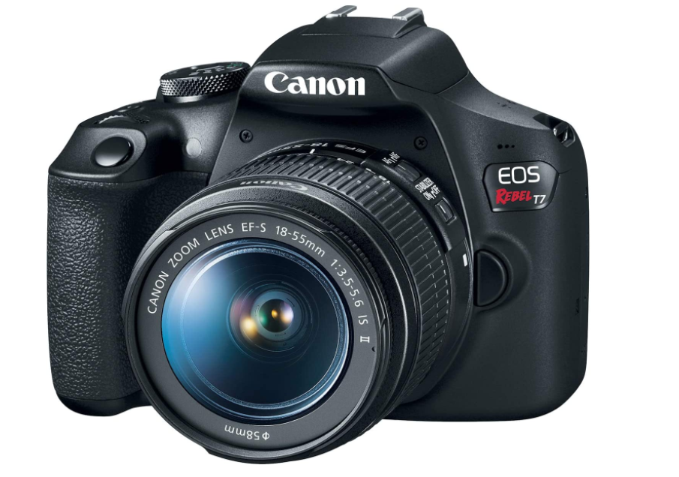

**Canon EOS Rebel T7**

* **24.1 Megapixel CMOS (APS-C) sensor with is 100–6400 (H: 12800)**
* **Built-in Wi-Fi and NFC technology**
* **9-Point AF system and AI Servo AF**
* **Optical Viewfinder with approx 95% viewing coverage**
* **Use the EOS Utility Webcam Beta Software (Mac and Windows) to turn your compatible Canon camera into a high-quality webcam. Compatible Lenses- Canon EF Lenses (including EF-S lenses, excluding EF-M lenses)**

**Price $1,598.00**